Creating a New Dashboard Report (Updated 5/2/2019)

Make a new branch off the Dashboard repo for your ticket and git checkout to it.

You must open via this solution file (dashboard.sln) in order to maintain the proper namespace across all files in the project. Add new files to the project via the solution explorer that is built in Visual Studio. For “aspx” files choose “Web Form” from the “add new item” dialog. For SQL and JavaScript choose “Text file” from the “Web Form” dialog and rename to either “.sql” or “.js” extension respectively.

Files that will need to be created under the “reports” directory
- your_report_name.aspx
- your_report_name _body.aspx
- your_report_name _generate.aspx
- your_report_name.sql

Files that will need to be created under the “javascript” directory
- your_report_name.js

Files that will need to be created under the “reports/ templates” directory
This template can also be added by “add existing item…” if the template has already been created.
- your_report_name.xlsx

- Select a previously made report that closely matches the inputs you’ll need. (i.e. date pickers, input fields, buttons). This report will be used as a reference to base the new report off of.

- Creating your_report_name.aspx
- Copy the entire design contents of the reference “.aspx” file, all lines except for the very first line i.e. "<%@ Page Language="C#" AutoEventWireup="true" CodeBehind=" etc. and paste it over the design contents of your_report_name.aspx (keeping the original first line of the your_report_name.aspx )
- Change the <title> tag to something relevant (i.e. <title>Report Name</title>)
- Copy the contents of the Page_Load function from the reference report’s “.aspx.cs” into the Page_Load function of your_report_name.aspx.cs
- Change the body.Value line of the Page_Load to point to "/reports/reportname_body.aspx"

- Creating your_report_name _body.aspx
- Copy the entire design contents of the reference report’s “_body.aspx” except for the very first line (i.e. "<%@ Page Language="C#" AutoEventWireup="true" CodeBehind=" etc.) and paste it over the design contents of your_report_name _body.aspx (keeping the original first line or your_report_name_body.aspx)
- You need to modify the second line to point to ../javascript/ your_report_name.js
- Modify the contents of the "container" div contained in the "definition" div. You should enter a very descriptive definition here. Anybody who uses your report should be able to tell what it does by reading it.
- In the "controls" div modify the <h1> tag to reflect your report.
- If needed modify the "controls" div to contain the controls your end user will need to generate their report. You can do this directly through the xhtml or by dynamically generating controls in the Page_Load function. (you can browse other reports to see examples.) (mgh_eligibility_body is a good example of dynamically generated controls based off database contents. uneligible_members_body is a good example of directly entered controls)

- Creating your_report_name_generate.aspx

(if you need an example of multi tab spreadsheets look at abw_benefit_code_summary_generate.aspx.cs)

- Delete all the page design contents except for the first line (i.e. keep <%@ Page Language="C#" AutoEventWireup="true" CodeBehind=" ... )
- Replace the using statements at the top of the your_report_name _generate.aspx.cs with the using statements from the reference report’s “_generate.aspx.cs” file.
- Copy the entire contents of the “Page_Load” method from the reference report’s “_generate.aspx.cs” file and paste it into the “Page_Load” method in your your_report_name _generate.aspx.cs
- Modify the “output_prefix” to represent the name you want your output .xlsx to be named.
- Modify / Add in values to the criteria “c” List. These values are a pair of “what to be replaced” and “value to replace with”. Everything found in this List will be applied to your sql queries before they are ran.
- Modify the Arguments variable “args” appropriately. You will need to supply connection strings,
“location = “,
“query_path =”,
“template_path”,
set equal to your corresponding report file, sheetname on the template to use, and starting row for the template. Read through the comments in the reference report’s “generate.aspx.cs” for detailed descriptions of the required arguments.

- Converting to new GenerateExcel_FromTabbedTemplate.exe Utility
- your_report_name_generate.aspx.cs may have to be converted to use the new Generate utility if the reference report it was based on used the old code.
- If the generate.aspx.cs file uses Dictionary<string, string> then it will need to be converted. Example below of old code :
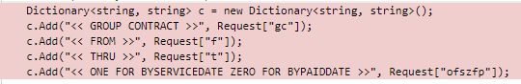

- Document to convert to new coding standard is in the Dashboard Repo titled “Conversion to new GenerateExcel_FromTabbedTemplate.exe Utility”

- Example Code below is part of the changes when switching to new Utiltity funciton.
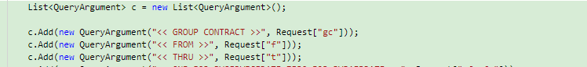

- Creating your_report_name.sql
- Use temporary tables or table variables or if you must ust tempdb for normal tables. Everything should be included in this one sql script.

(Though with new Gernerate Utility each new sheet on the excel template can be populate using a different SQL program)

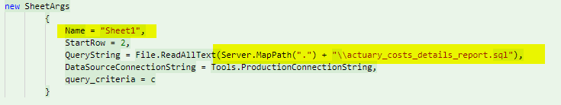

Pretty much anything goes as long is the query runs reasonably fast and you're not making tables in the Production database. Also, the your_report_name _generate.aspx file is set up to replace test phrases in this file. E.g. select * from table where criteria = <<criteria>>. You can have generate replace <<criteria>> with some criteria generated by your users on the your_report_name _body.aspx.

- Creating your_report_name.js
- Copy over the reference report’s “.js” file to your_report_name.js.
- You need this at the top, if not already present.
// This reference gives jquery the intellesense feature
/// <reference path="jquery-vsdoc.js" />

// Disable caching of ajax responses
$.ajaxSetup({ cache: false });
it allows for intellesense and non-cached ajax responses.
- The JavaScript file does the following:
- hides progressbar
- handles generate clicks
- Disable the generate button on clicks
- Fade out the download link and fade in the progress bar on clicks
- Compile all the users input into appropriate input format for your generate.aspx file. (these options get passed through a JSON variable string.
- Fire off the generate.aspx file (make sure you are pointing to your_report_name_generate.aspx and not the previous report’s.)

- On completion of the generate.aspx fire off - we must begin checking the progress
- Your generate.aspx will need to return a div containing
- location
- accessed
- username
- output directory
5 ) This file will also have to deal with any custom control handling on the page. You can see how other reports’ JavaScript file deals with date pickers.

-- Like I said look over mgh_eligibility.js for a good example. And follow the section C for creating your generate.aspx

- Creating your_report_name.xlsx
- You can format this pretty much any way you see fit. You can have borders, headers, footers, set up your margins, background colors, different fonts, sizes, etc. etc. Make sure the row that data starts to populate is accurate in the generate.aspx.cs
- The only real rule here is allow for the data to be entered in a square pattern. E.g. columns and rows.
- Make sure the start row under _generate.aspx.cs corresponds to the row you want data to start to populate in your template.
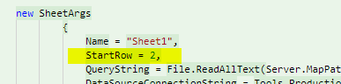

- Files and Permissions
- Make sure you have admin access for dashboard/admin.aspx
- Add new report using “+” in corner of Silverlight / Report box.
- Add yourself as Assigned Users to the report.

